In order to run the above uasset and the umap file, the user needs an Unreal Engine 4 installed on their system and load the level in their Unreal Engine editor.

**Description:** I have built a house with two floors which consists of 5 rooms without the living room being included. The level 1 i.e., the floor 1 consists of a living room, kitchen , bedroom and a small reading place. The level 2 i.e., the floor 2 consists of two bedrooms and a study room. The stair way which is built on the living room will lead to the level 2.

**Environment in which it is built:**

Dell Inspiron 15

Processor: i7 8th gen processor

Ram – 16.00 GB

System Type: 64-bit Operating system, x-64 based processor

**Assets, contents, lights used in the house:**

The assets includes Round Tables, Chair, Pillars, Door Frame, Furnitures, Flower vase.

The kitchen includes microwave, tea pot, Cab low sink, faucet, freezer, Sink, Refrigerator, Oven.

The window was built with frame and the bay window was put into use in the level 2 bedroom. The lights used were the Directional lights and the spotlights.

The props in the bedroom also included shelves, bed(made with the geometry), table holding the statues, bookshelves, Cab low drawers.

The project works perfectly fine with the two levels built in the unreal engine.

**Sketch: (Drawing)**

**Level 1:**

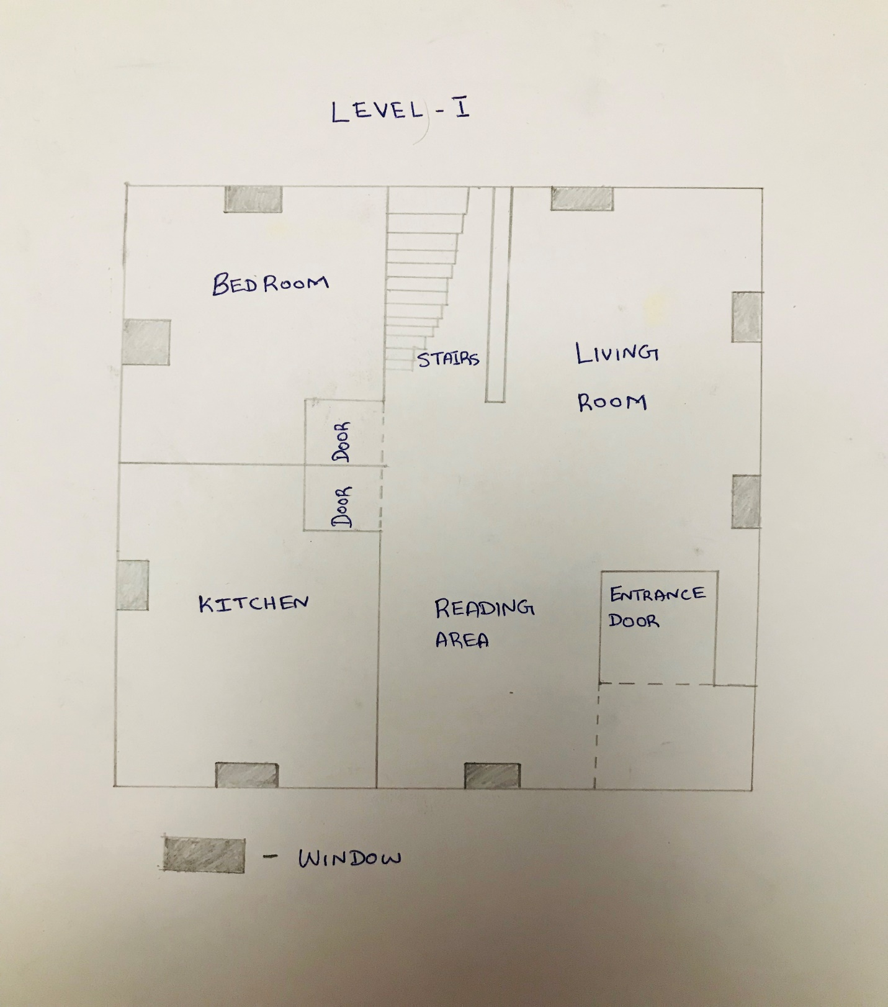

**Level-2**

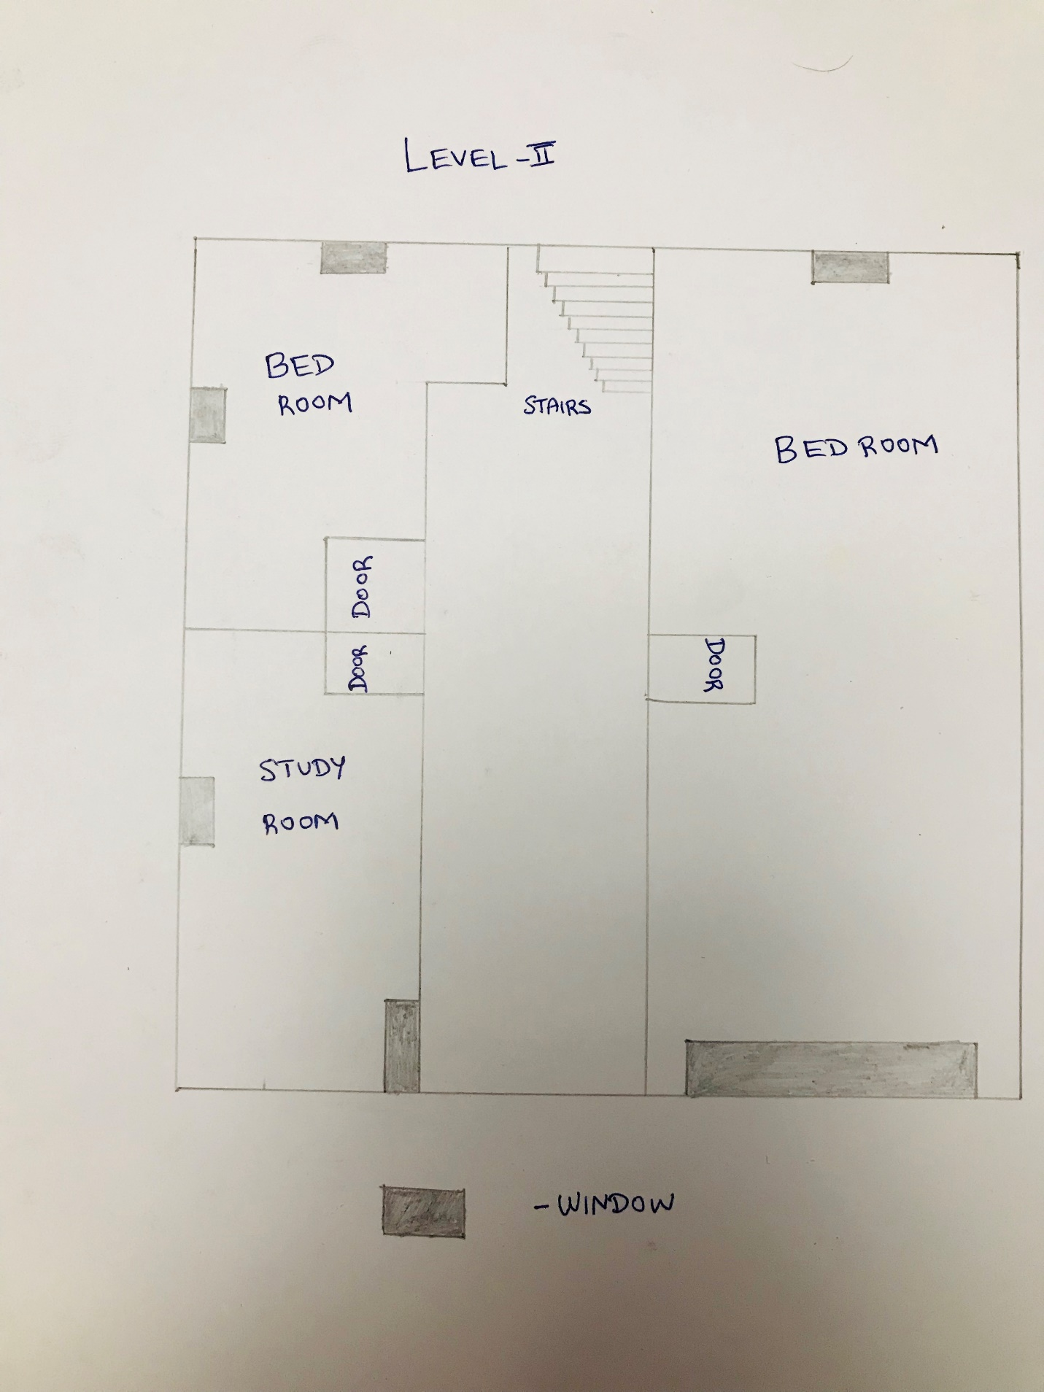

The below are the screen shots of the various rooms that were included in the project.

**Level – 1:**

1. Living Room 2) Reading Place 3) Kitchen 3) Bedroom

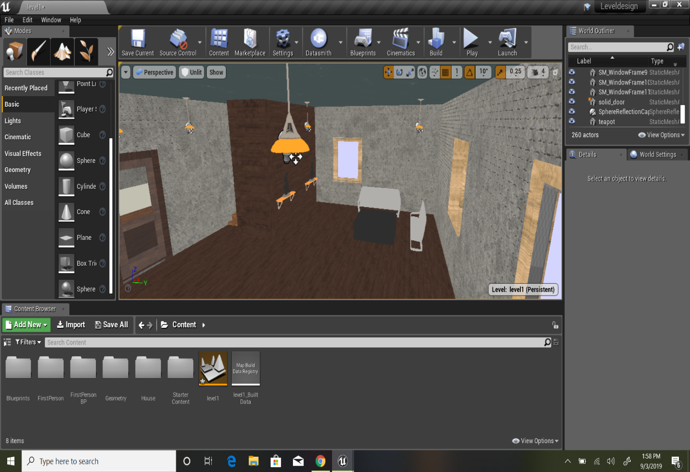

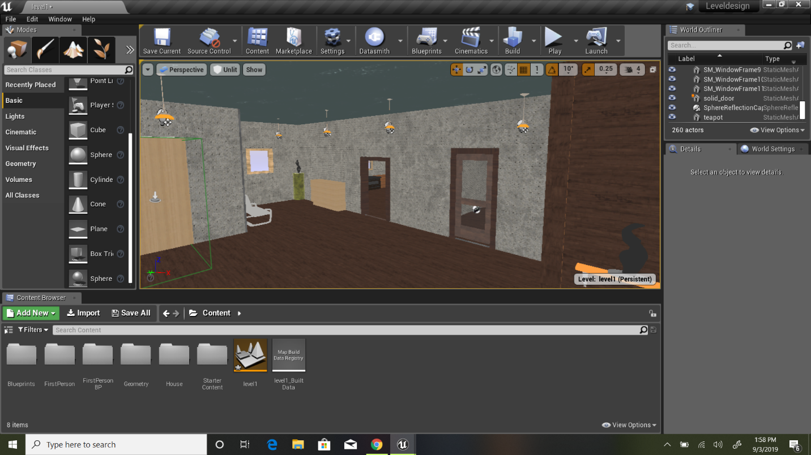

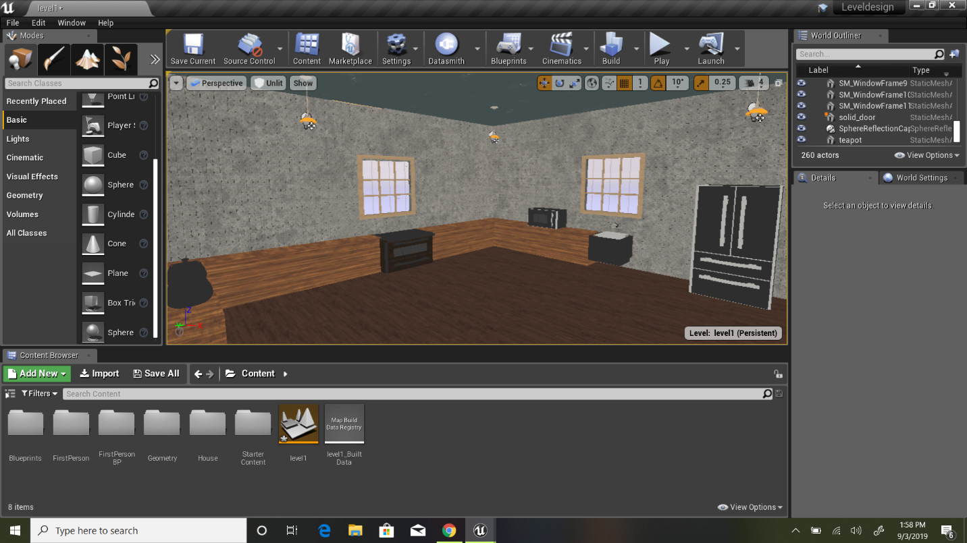

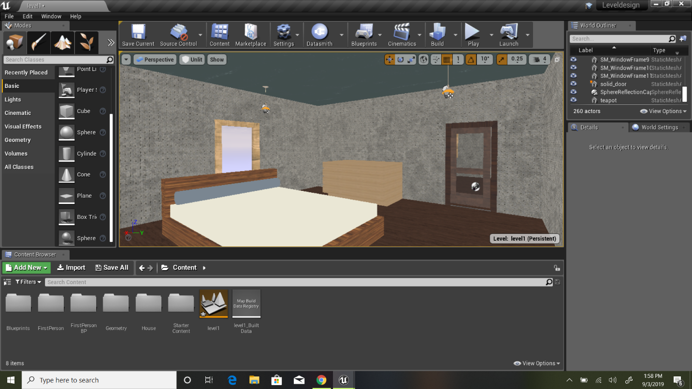

Level -2

1. Pathway leading to three rooms

2)Study Room

3)Bedroom

4)Bedroom

